Understanding Multiplicative Comparison

INSTRUCTIONAL ACTIVITY SUPPLEMENT A

Lesson 1

|  |
| --- |
| Ms. Smith has three students in each of her small groups for reading. If she has six small groups, how many students does Ms. Smith meet with for reading? |
| Mitchel, Brenna, and Ana need six notecards for a group project. Mitchel has three notecards, Brenna has two notecards, and Ana has zero notecards. Do they have enough notecards for their group project? |
| Mr. Gonzales needs 100 two-liter bottles for a science project. If each of his 23 students brings in three two-liter bottles, will Mr. Gonzales have enough two-liter bottles for the science project? |
| Jackie is getting a new blanket for her bed. The area of her bed is 28 feet. Jackie wants her blanket to be larger than her bed. The blanket she picks is six feet long and four feet wide. Will the blanket Jackie picked be larger or smaller than her bed? |
| Marco is saving money for a new pair of headphones. He adds his allowance of $10 to his savings every week. How much money will Marco have saved after four weeks if he starts with $0 in his savings? |
| Mr. Jacobson is putting a fence up around Mrs. Jacobson’s garden. The garden is 10 feet long and four feet wide. If the fencing is sold in lengths of 20 feet, how many lengths will Mr. Jacobson need to buy? |
| Liam has to read four books before the school break. The first book has 176 pages, the second book has 103 pages, and the third and fourth books each have 98 pages. How many pages does Liam have to read before the school break? |
| Emma and Terrance are competing for the tallest cup stack. Emma has 55 cups stacked so far, and Terrance has 62 cups stacked so far. How many cups does Emma need to add to her stack to beat Terrance, if Terrance does not add any more cups? |
| Becca is picking berries with her family. Each pail holds four pints of berries. Becca fills four pails, and her sister fills three pails. How many pints of berries do Becca and her sister collect altogether? |
| Mia and Ruby are making a poster for their social studies project. They want their poster to be blue on the top half and green on the bottom half to look like the sky and grass. They buy a blue poster board that is 18 inches long and 24 inches wide. What is the area of the poster board they need to paint? |
| Each week, Elias brings his lunch from home for three days and buys school lunch for two days. Each school lunch costs $2. How much will Elias spend on school lunches after four weeks? |
| Each window on a house has four pieces of glass. If there are seven windows, how many total pieces of glass make up all the windows? |
| Zoey ordered six books online, and Brayden ordered eight books online. If their books arrive together in the same box, how many books will there be? |
| Aaliyah is hanging curtains in her bedroom. If the area of each of her windows is 6 square feet, will a curtain that is five feet long and 3 feet wide be large enough to cover a whole window? |
| The area of the playground at Stuart elementary school is 792 square feet. If the school adds a second playground of the same size, what will be the total square feet of the two playgrounds? |
| Devin and Leah are using their base-ten blocks in math class. Devin has 6 groups with 3 ones in each group. Leah has 9 groups with 2 ones in each group. Are Devin and Leah using the same number of base-ten blocks for the problem they are modeling? |

|  |
| --- |
| Equal-Groups Multiplication Problems |
| Measurement Multiplication Problems |
| Addition Problems |



Understanding Multiplicative Comparison

INSTRUCTIONAL ACTIVITY SUPPLEMENT B

Lesson 1

***Making Matches* Game**

The goal of the game is to collect as many pairs of example cards and problem type cards as possible.

Directions:

1. One student mixes the cards and passes out four cards to each student in the group. Then that student places four cards face up in the center of the group.
2. On each turn, a student has two choices:
   1. Take a center card and make a pair with a card in their hand.
   2. Leave a card in the center face up.

*All pairs must be placed face up so the group can verify that the match is correct*.

1. After each student has had one turn, the student who dealt the cards gives everyone in the group one more card.
2. Repeat steps 2 and 3 until there are not more cards.
3. The student with the most pairs/matches wins.

\* Recommend printing the cards on tag board or card stock to last longer.

|  |  |  |  |
| --- | --- | --- | --- |
| multiplicative comparison | Seth’s grandma is 6 times older than he is. If Seth is 9 how old is his grandma? | equal-groups multiplication | Danny saves $5 every month. How much will Danny have in 4 months if he starts with $0? |
| additive comparison | Every day, Sally gives her dog three treats and her cat two treats. How many more treats does her dog get than her cat every day? | measurement multiplication | Jackie is getting a new blanket for her bed. The area of her bed is 28 square feet. Jackie wants her blanket to be larger than her bed. The blanket she picks is 6 feet long and 4 feet wide. Will the blanket Jackie picked be larger or smaller than her bed? |
| multiplicative comparison | Jess picked four apples. John picked three times as many apples as Jess did. How many apples did John pick? | equal-groups multiplication | Ms. Smith has three students in each of her small groups for reading. If she has six small groups, how many students does Ms. Smith meet with for reading? |
| additive comparison | Maria has 6 sharpened pencils in her desk. Max has 2 sharpened pencils in his desk. How many more pencils does Maria have than Max? | measurement multiplication | Juan is making a board game for a math project. He is designing the board like a table, divided into rows and columns. If he has 7 rows and 4 columns, how many squares will he have on his game board? |
| multiplicative comparison | Makayla did not do all of her reading homework for the week. Braxton did all of his reading homework for the week on time. Braxton read 33 pages, and he read 3 times more than Makayla. How many pages will Makayla have to read to catch up? | equal-groups multiplication | Each window on a house has four pieces of glass. If there are seven windows, how many total pieces of glass make up all the windows? |
| additive comparison | Evan and Josiah were collecting empty cans to recycle. Evan collected five more cans than Josiah. If Evan collected 12 cans, how many cans did Josiah collect? | measurement multiplication | The grass on the soccer field is being replaced. The soccer field is 20 feet long and 57 feet wide. What is the total area of new grass needed to cover the soccer field? |
| multiplicative comparison | Trenton’s older brother Jaxson has 120 minutes of homework a week. Trenton has 40 minutes of homework a week. How many times more does Jaxson spend on homework than Trenton each week? | equal-groups multiplication | Jayla has 20 minutes of homework each night Monday through Thursday. How many minutes of homework does Jayla have each school week? |
| additive comparison | Chase has 15 minutes of homework on Tuesday and 27 minutes of homework on Wednesday. How much more time did Chase spend on homework on Tuesday than Wednesday? | measurement multiplication | For homework, Antonio has to make a paper quilt with each square representing an event in the American Revolution. His quilt is made of 42 paper squares, and the length of the paper quilt is 7 paper squares. How many paper squares wide is Antonio’s quilt? |
| multiplicative comparison | During the science experiment, it took the water 2 times longer to have a reaction than the oil. The oil took 13 minutes. How long did the water take? | equal-groups multiplication | During the science experiment, the teacher gave each group of students five tablespoons of oil. There are eight groups in the science class. How many tablespoons of oil will the science teacher need? |
| additive comparison | For the science experiment, the students used baking soda and oil. Each group was given five tablespoons of oil and two tablespoons of baking soda. How much more oil did the students get than baking soda? | measurement multiplication | The students recorded their data from the science experiment in a table. There were 3 columns and 12 rows. How many total cells are in the table? |

Understanding Multiplicative Comparison

Lesson 2

Use the information you are given to fill in the blank sections.

1.

|  |  |
| --- | --- |
| **Problem situation** | Rylee has six times more trading cards than Justice. If Justice has twelve trading cards, how many trading cards does Rylee have? |
| **Restate the question in your own words** |  |
| **Model** |  |
| **Solution** |  |

2.

|  |  |
| --- | --- |
| **Problem situation** | Justice, Rylee, and Theo are going to play a game with their trading cards. To prepare, Theo arranges his cards into stacks. He makes five stacks with six cards in each stack. How many trading cards does Theo have? |
| **Restate the question in your own words** |  |
| **Model** |  |
| **Solution** |  |

3.

|  |  |
| --- | --- |
| **Problem situation** |  |
| **Restate the question in your own words** |  |
| **Model** | /Users/trevoreagleman/Desktop/4.OA.1,2_instructional_activity_handout_lesson_2-01.jpg |
| **Solution** |  |

4.

|  |  |
| --- | --- |
| **Problem situation** | Bella runs with her dad every Saturday morning. Bella’s mom and little sister walk every Saturday morning. Bella and her dad run three times as far as her mom and little sister walk. If Bella and her dad run six miles, how far do her mom and little sister walk? |
| **Restate the question in your own words** |  |
| **Model** |  |
| **Solution** |  |

5.

|  |  |
| --- | --- |
| **Problem situation** | Bella has to get new running shoes every 4 months. Bella’s little sister Emma gets new walking shoes every 7 months. How many months after Bella gets new running shoes will Emma get her new walking shoes? |
| **Restate the question in your own words** |  |
| **Model** |  |
| **Solution** |  |

6.

|  |  |
| --- | --- |
| **Problem situation** |  |
| **Restate the question in your own words** |  |
| **Model** | /Users/trevoreagleman/Desktop/4.OA.1,2_instructional_activity_handout_lesson_2-02.jpg |
| **Solution** |  |

Understanding Multiplicative Comparison

INSTRUCTIONAL ACTIVITY SUPPLEMENT

Lesson 2

**Model A**



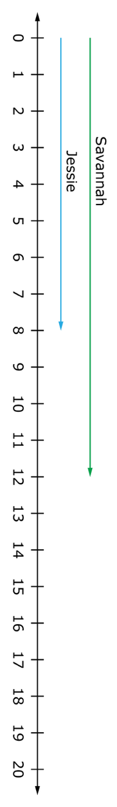**Model B**

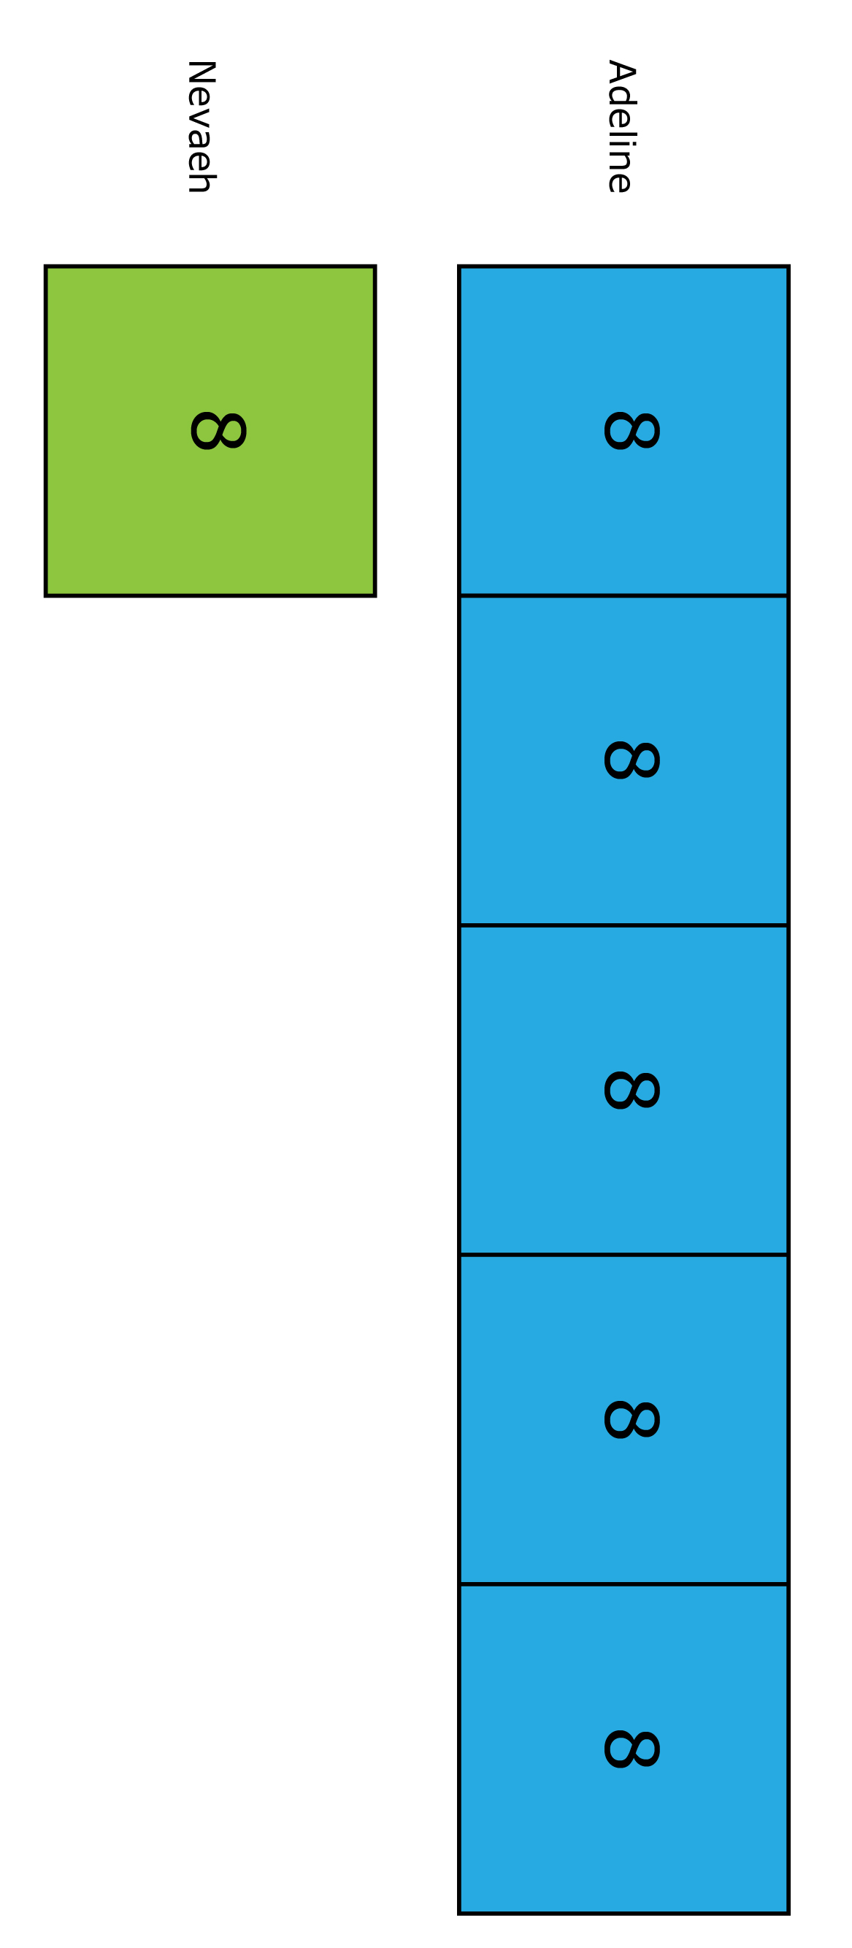**Model C**

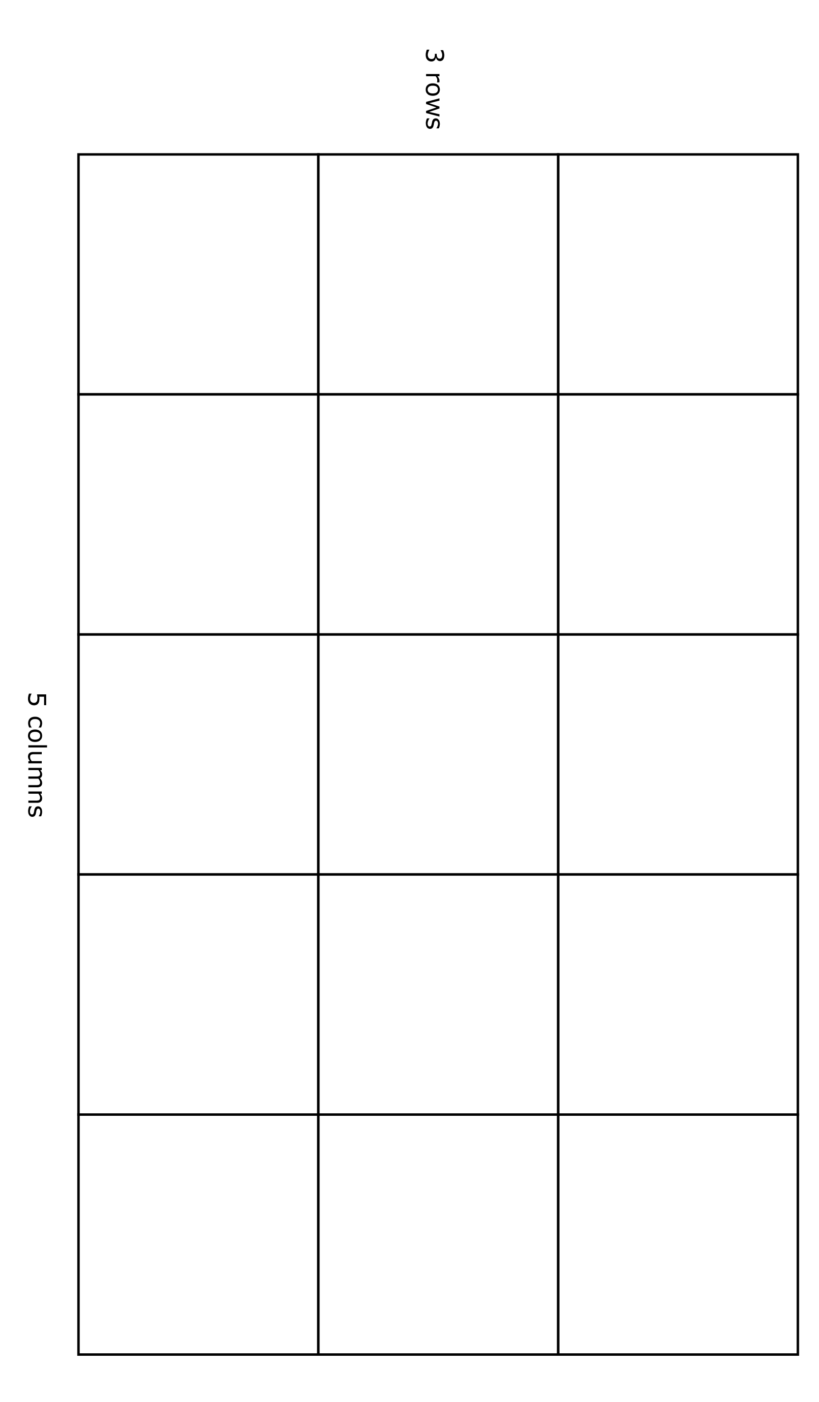**Model D**

**Model E**



Understanding Multiplicative Comparison

Lesson 3

Choose four task cards to use to complete the tables.

1.

|  |  |
| --- | --- |
| **Task Card Number** |  |
| **Restate the question in your own words** |  |
| **Model** |  |
| **Equation** |  |
| **Solution** |  |

2.

|  |  |
| --- | --- |
| **Task Card Number** |  |
| **Restate the question in your own words** |  |
| **Model** |  |
| **Equation** |  |
| **Solution** |  |

3.

|  |  |
| --- | --- |
| **Task Card Number** |  |
| **Restate the question in your own words** |  |
| **Model** |  |
| **Equation** |  |
| **Solution** |  |

4.

|  |  |
| --- | --- |
| **Task Card Number** |  |
| **Restate the question in your own words** |  |
| **Model** |  |
| **Equation** |  |
| **Solution** |  |

Understanding Multiplicative Comparison

INSTRUCTIONAL ACTIVITY SUPPLEMENT

Lesson 3

|  |  |
| --- | --- |
| $$+$$ | $$+$$ |
| $$×$$ | $$×$$ |
| $$÷$$ | $$÷$$ |
| $$=$$ | $$=$$ |
| ? | ? |
| ☐ | ☐ |
| 1 | 1 |
| 1 | 2 |
| 2 | 2 |
| 3 | 3 |
| 3 | 4 |
| 4 | 4 |
| 5 | 5 |
| 5 | 6 |
| 6 | 6 |
| 7 | 7 |
| 7 | 8 |
| 8 | 8 |
| 9 | 9 |
| 9 | 0 |
| 0 | 0 |

**Task Cards**

|  |
| --- |
| \\cfs.home.ku.edu\aai_general\Projects\DLM Image Library\catalogs\Math_images\people\girl_boxing_books(stem).jpgTask #1  Ms. Smith has 3 students in each of her small groups for reading. If she has 6 small groups, how many students does Ms. Smith meet with for reading? |
| \\cfs.home.ku.edu\aai_general\Projects\DLM Image Library\catalogs\Math_images\animals\animals_groups_dog_cat(stem).jpg Task #2  Every day, Sally gives her dog three treats and her cat two treats. How many more treats does her dog get than her cat every day? |
| \\cfs.home.ku.edu\aai_general\Projects\DLM Image Library\catalogs\Math_images\people\woman_holding quilt(stem).jpgTask #3  Jackie is getting a new blanket for her bed. The area of her bed is 28 square feet. Jackie wants her blanket to be larger than her bed. The blanket she picks is 6 feet long and 4 feet wide. Will the blanket Jackie picked be larger or smaller than her bed? |
| \\cfs.home.ku.edu\aai_general\Projects\DLM Image Library\catalogs\Math_images\household_items\officeschool suplies\_groups\pencils_4.jpgTask #4  Maria has six sharpened pencils in her desk. Max has two sharpened pencils in his desk. How many more pencils does Maria have than Max? |
| Task #5  \\cfs.home.ku.edu\aai_general\Projects\DLM Image Library\catalogs\Math_images\household_items\books\big_book(stem).jpgMakayla did not do all of her reading homework for the week. Braxton did all of his reading homework for the week on time. Braxton read 33 pages, and he read 3 times more than Makayla. How many pages will Makayla have to read to catch up? |
| \\cfs.home.ku.edu\aai_general\Projects\DLM Image Library\catalogs\Math_images\money\5_dollar\5dollarbill_simplified_250x130_(stem).jpgTask #6  Danny saves $5 every month. How much will Danny have in 4 months if he starts with $0? |
| \\cfs.home.ku.edu\aai_general\Projects\DLM Image Library\catalogs\Math_images\people\both_homework_math(stem).jpgTask #7  Trenton’s older brother Jaxson has 120 minutes of homework a week. Trenton has 40 minutes of homework a week. How many times more does Jaxson spend on homework than Trenton? |
| Task #8  \\cfs.home.ku.edu\aai_general\Projects\DLM Image Library\catalogs\Math_images\measurement\_size_comparison\game_board_with_square_large.jpgJuan is making a board game for a math project. He is designing the board like a table, divided into rows and columns. If he has seven rows and four columns, how many squares will he have on his game board? |
| Task #9  /Users/trevoreagleman/Desktop/beakers_water_oil_stem.jpgDuring the science experiment, it took the water 2 times longer to have a reaction than the oil. The oil took 13 minutes. How long did the water take? |
| /Users/trevoreagleman/Desktop/paper_unlabeled_grid_paper.jpgTask #10  The students recorded their data from the science experiment in a table. There were 3 columns and 12 rows. How many total cells are in the table? |
| /Users/trevoreagleman/Desktop/house_house_blueprint.jpgTask #11  Each window on a house has four pieces of glass. If there are seven windows, how many total pieces of glass make up all the windows? |
| /Users/trevoreagleman/Desktop/boy_grandma-01.jpgTask #12  Seth’s grandma is six times older than he is. If Seth is nine, how old is his grandma? |

Understanding Multiplicative Comparison

Lessons 1 – 3

1. Identify the following problem situations by writing the type under each problem. Explain your answer using words, numbers, and/or models.

|  |  |
| --- | --- |
| **Word Bank** | |
| Additive comparison | Equal-groups multiplication |
| Measurement multiplication | Multiplicative comparison |

Use the word bank to help you write the type of problem. Notice that there are more types than there are problems.

* 1. The school student council is having a food drive. So far, the fourth-grade classes combined have brought in three times as many items as the fifth-grade classes. The fourth-grade classes have brought in 132 items. How many items have the fifth-grade classes collected?  
       
     Problem type:

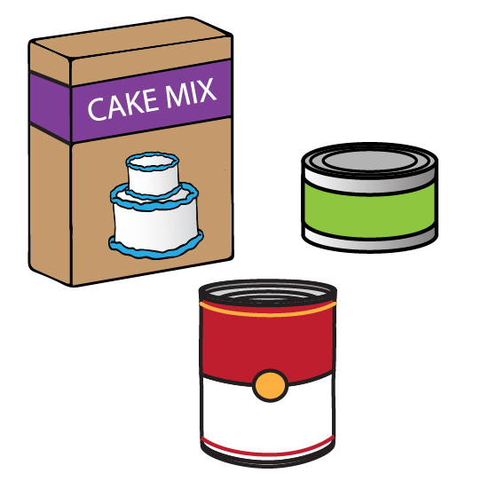

I know this because:

* 1. So far, Mr. Snow’s fourth-grade class has brought in 32 more items for the food drive than Ms. Hart’s third-grade class. Ms. Hart’s class has brought in 86 items. How many items has Mr. Snow’s class brought in for the food drive?  
       
     Problem type:  
       
     I know this because:



* 1. The student council has to box up all of the items from the food drive so the items can be delivered. They can fit eight items in each box. So far, they have filled twenty-three boxes. How many items have the student council boxed up so far?  
       
     Problem type:  
       
     I know this because:

1. Finish each table using the information provided.

|  |  |
| --- | --- |
| **Problem situation** |  |
| **Restate the question in your own words** |  |
| **Model** | /Users/trevoreagleman/Desktop/4.OA.1,2_student_activity-01.jpg |
| **Solution** |  |

|  |  |
| --- | --- |
| **Problem situation** | /Users/trevoreagleman/Desktop/4.OA.1,2_student_activity-02.jpgMs. Griggs, the P.E. teacher, has 15 playground balls that can be used for kickball or four square. The fourth-grade teachers have 3 playground balls that can be used for kickball or four square. Ms. Griggs has how many times more playground balls than the fourth-grade teachers? |
| **Restate the question in your own words** |  |
| **Model** |  |
| **Solution** |  |



|  |  |
| --- | --- |
| **Problem situation** | /Users/trevoreagleman/Desktop/4.OA.1,2_student_activity-02.jpgMs. Griggs, the P.E. teacher, has 15 playground balls for kickball and four square. There are three different colors: red, blue, and green. There are five green balls and four more blue balls than red balls. If there are three red balls, how many blue balls are there? |
| **Restate the question in your own words** |  |
| **Model** |  |
| **Solution** |  |

1. Using the information given, write an equation.
   1. Forty-two is six times more than seven.

* 1. 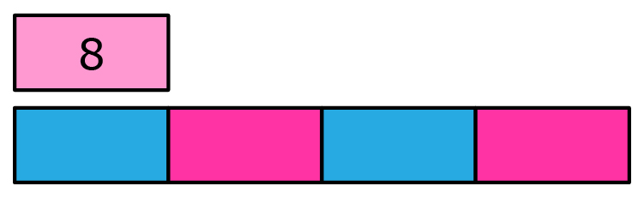
  2. ☐ is 9 times less than 45.

1. 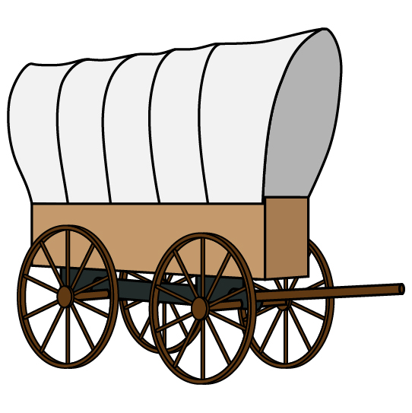Pedro and Jayce are creating a digital poster for their social studies assignment on Westward Expansion. They have to have at least 6 facts and 4 pictures. If Pedro finds 2 facts, and Jayce finds 3 facts more than Pedro, will they have enough facts? Show your work using words, models, and/or equations.
2. Harper and Mason are making a video for their social studies assignment on Westward Expansion. They are using four times more pictures than Pedro and Jayce. If Harper and Mason are using twenty pictures, how many pictures are Pedro and Jayce using? Show your work using words, models, and/or equations.
3. 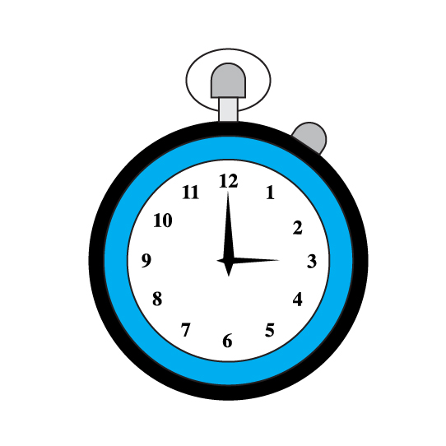Mr. Swaim, the social studies teacher, gives the students 10 minutes to present their Westward Expansion projects. Pedro and Jayce take 7 minutes to present. When Harper and Mason timed their video, it was 3 times longer than the presentation by Pedro and Jayce. How much time will Harper and Mason need to present their video in full? Will that amount of time be longer than, shorter than, or the same amount of time Mr. Swaim will allow? Show your work using words, models, and/or equations.